ID:7
Shital Digambar Bhadre.
Reg No:260640160611
Utkarsha Subhash Pawar.
Reg No:260640160985

Assignment 1

1. Write a C++ program to create a namespace named Math that contains a function void square(int) to calculate the square of a number. Access the function using the scope resolution operator.
#include <iostream>
using namespace std;
namespace Math {

int square(int n) {
return n * n;
}

}

int main() {
int number;

cout << "Enter an integer: ";
cin >> number;

cout << "Square of " << number << " is " << Math::square(number) << endl;

return 0;
}

Output:

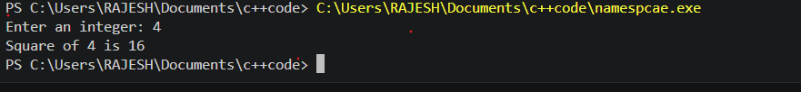

2.Create a namespace named Calculator containing the following functions:
add()
subtract()
multiply()
divide()
Write a menu-driven program to perform arithmetic operations using namespace functions.
#include<iostream>
using namespace std;
namespace calculator
{
void add(int a,int b)
{
cout<<a<<"\n"<<b<<a+b<<endl;
}

void sub(int a,int b){
cout<<a<<"\n"<<b<<a-b<<endl;
}

void mul(int a,int b){
cout<<a<<"\n"<<b<<a*b<<endl;
}

void divide(float a,float b){
cout<<a<<"\n"<<b<<a/b<<endl;
}

}
int main(){
int choice,num1,num2;
cout<<"_____choice______";
cout<<"1.addition:\n";
cout<<"2.subtraction:\n";
cout<<"3.multiplcation:\n";
cout<<"4.division:\n";
cout<<"5.Exit\n";
cout<<"Enter your choice:"<<endl;
cin>>choice;
cout<<"Enter 2 no:\n";
cin>>num1>>num2;
switch(choice)
{
case 1:
cout<<num1+num2;
break;

case 2:
cout<<num1-num2;
break;

case 3:
cout<<num1*num2;
break;

case 4:
cout<<num1/num2;
break;

default:
cout<<"Exit";
}
return 0;

}

Output:

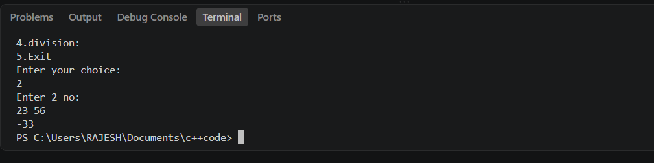

3.Create two namespaces:
Rectangle
Circle
The Rectangle namespace should calculate area of rectangle.
The Circle namespace should calculate area of circle.
Allow the user to select which area to calculate.
#include <iostream>
#define _USE_MATH_DEFINES //is a preprocessor macro used in C/C++ programs.
#include <cmath> //mathematical functions and macros for numeric computations.

namespace Rectangle {
double area(double length, double width) {
return length * width;
}
}

namespace Circle {
double area(double radius) {
return M_PI * radius * radius;
}
}

int main() {
int choice;

std::cout << "Select shape to calculate area:";
std::cout << "1. Rectangle";
std::cout << "2. Circle";
std::cout << "Enter choice (1 or 2): ";
std::cin >> choice;

if (choice == 1) {
double length, width;
std::cout << "Enter length of rectangle: ";
std::cin >> length;
std::cout << "Enter width of rectangle: ";
std::cin >> width;
std::cout << "Area of Rectangle = " << Rectangle::area(length, width) << std::endl;
}
else if (choice == 2) {
double radius;
std::cout << "Enter radius of circle: ";
std::cin >> radius;
std::cout << "Area of Circle = " << Circle::area(radius) << std::endl;
}
else {
std::cout << "Invalid choice. Please select 1 or 2." << std::endl;
}

return 0;
}

Output:

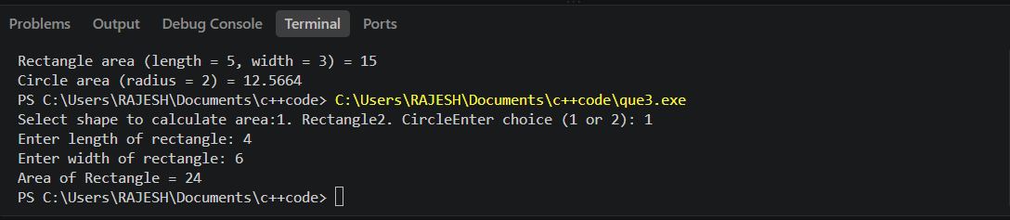

4. Create two namespaces:
namespace India
namespace USA
Each namespace should have a function named currency().
#include <iostream>
#include <string>

// Namespace for India
namespace India {
void currency() {
std::cout << "Indian currency: Indian Rupee (INR)" << std::endl;
}
}

// Namespace for USA
namespace USA {
void currency() {
std::cout << "USA currency: United States Dollar (USD)" << std::endl;
}
}

int main() {
try {
// Calling currency() from India namespace
India::currency();

// Calling currency() from USA namespace
USA::currency();
}
catch (const std::exception &e) {
std::cerr << "Error: " << e.what() << std::endl;
return 1;
}

return 0;

}

Output:
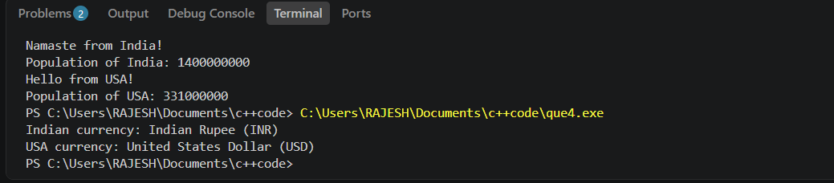

5.Create a namespace named Student having
rollNo
name
display()
Use the using namespace directive to access members without using scope resolution operator.
#include <iostream>
#include <string>
using namespace std;

// Defining the namespace
namespace Student {
int rollNo;
string name;

void display() {
cout << "Roll No: " << rollNo << endl;
cout << "Name: " << name << endl;
}
}

int main() {
using namespace Student;

rollNo = 101;
name = "Aarav Sharma";

display();

return 0;
}

Output:

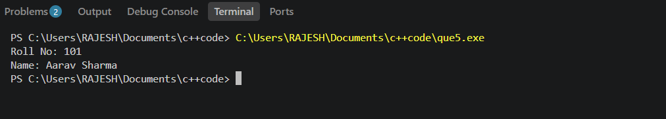

6. Write a C++ program that dynamically allocates memory for storing the marks of a student based on the number of subjects entered by the user.
The program should perform the following tasks:
1. Accept the number of subjects from the user.
2. Dynamically allocate memory to store the marks of all subjects.
3. Accept the marks for each subject.
4. Display the marks of all subjects.
5. Calculate and display the total (sum) of the marks.
6. Calculate and display the average marks obtained.
7. Deallocate the dynamically allocated memory before the program terminates to avoid memory leaks.

#include<iostream>
using namespace std;
int main()
{

int sub , *marks,sum=0;
float avg;
cout<<"Enter no of Subjects:\n";
cin>>sub;
marks=new int[sub];
cout<<"Enter"<<sub<<"\n marks:"<<endl;
for(int i=0;i<sub;i++){
cin>>marks[i];
sum +=marks[i];
}
avg = (float)sum/sub;
cout<<"\n Sum: "<<sum;
cout<<" Avg: "<<avg;

delete[] marks;
}

Output:

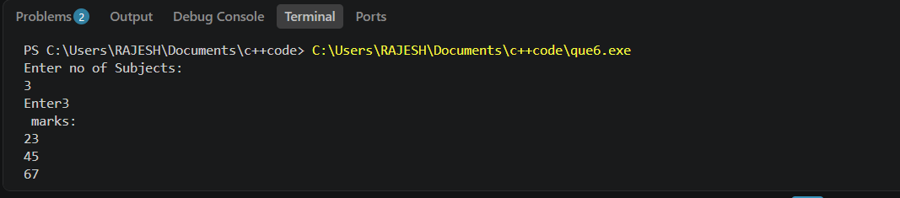

7. Write a C++ program that dynamically allocates memory for a 2D array to store the marks of multiple students in multiple subjects.
The program should perform the following tasks:
- Accept the number of students from the user.
- Dynamically allocate memory for a 2D array of size Students × Subjects.
- Accept the marks of each student in every subject.
- Display the marks in tabular format.
- Calculate and display the total and average marks for each student.
- Calculate and display the highest mark obtained among all students.
- Deallocate all dynamically allocated memory before the program terminates to prevent memory leaks.

Code:
#include <iostream>
#include <iomanip>
using namespace std;

int main() {
int numStudents, numSubjects;

// 1. Accept number of students and subjects
cout << "Enter number of students: ";
cin >> numStudents;
cout << "Enter number of subjects: ";
cin >> numSubjects;

// 2. Dynamically allocate memory for a 2D array (array of pointers)
int** marks = new int*[numStudents];
for (int i = 0; i < numStudents; i++) {
marks[i] = new int[numSubjects];
}

// 3. Accept marks for each student in every subject
for (int i = 0; i < numStudents; i++) {
cout << "\nEnter marks for Student " << i + 1 << ":\n";
for (int j = 0; j < numSubjects; j++) {
cout << " Subject " << j + 1 << ": ";
cin >> marks[i][j];
}
}

// 4. Display marks in tabular format
cout << "\n----- Marks Table -----\n";
cout << setw(10) << "Student";
for (int j = 0; j < numSubjects; j++) {
cout << setw(10) << ("Sub" + to_string(j + 1));
}
cout << setw(10) << "Total" << setw(10) << "Average" << endl;

// 5. Calculate and display total & average for each student
int highestMark = marks[0][0]; // for step 6
int highestStudent = 1, highestSubject = 1;

for (int i = 0; i < numStudents; i++) {
int total = 0;
cout << setw(10) << ("S" + to_string(i + 1));

for (int j = 0; j < numSubjects; j++) {
cout << setw(10) << marks[i][j];
total += marks[i][j];

// Track highest mark among all students
if (marks[i][j] > highestMark) {
highestMark = marks[i][j];
highestStudent = i + 1;
highestSubject = j + 1;
}
}

double average = static_cast<double>(total) / numSubjects;
cout << setw(10) << total << setw(10) << fixed << setprecision(2) << average << endl;
}

// 6. Display highest mark among all students
cout << "\nHighest mark obtained: " << highestMark
<< " (Student " << highestStudent << ", Subject " << highestSubject << ")" << endl;

// 7. Deallocate all dynamically allocated memory
for (int i = 0; i < numStudents; i++) {
delete[] marks[i];
}
delete[] marks;

return 0;
}

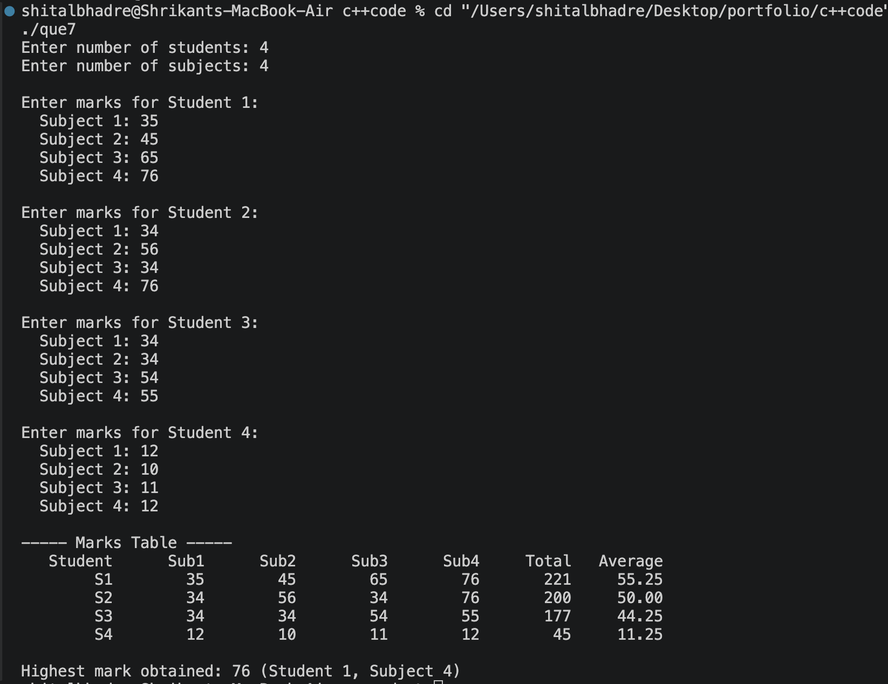

- Write a C++ program that dynamically allocates a 2D array to store the monthly sales of different products. The program should:
  - Accept the number of products.
  - Accept the number of months.
  - Store the sales data.
  - Display the sales report.
  - Calculate:
  - Total sales of each product.
  - Total sales for each month.
  - Grand total of all sales.
  - Deallocate the memory.

#include <iostream>
#include <iomanip>
using namespace std;

int main() {
int numProducts, numMonths;

cout << "Enter number of products: ";
cin >> numProducts;
cout << "Enter number of months: ";
cin >> numMonths;

int** sales = new int*[numProducts];
for (int i = 0; i < numProducts; i++) {
sales[i] = new int[numMonths];
}

for (int i = 0; i < numProducts; i++) {
cout << "\nEnter sales for Product " << i + 1 << ":\n";
for (int j = 0; j < numMonths; j++) {
cout << " Month " << j + 1 << ": ";
cin >> sales[i][j];
}
}

int* monthTotal = new int[numMonths];
for (int j = 0; j < numMonths; j++) {
monthTotal[j] = 0;
}

cout << "\n----- Sales Report -----\n";
cout << setw(10) << "Product";
for (int j = 0; j < numMonths; j++) {
cout << setw(10) << ("M" + to_string(j + 1));
}
cout << setw(12) << "Total" << endl;

long grandTotal = 0;

for (int i = 0; i < numProducts; i++) {
int productTotal = 0;
cout << setw(10) << ("P" + to_string(i + 1));

for (int j = 0; j < numMonths; j++) {
cout << setw(10) << sales[i][j];
productTotal += sales[i][j];
monthTotal[j] += sales[i][j];
}

cout << setw(12) << productTotal << endl;
grandTotal += productTotal;
}

cout << setw(10) << "Total";
for (int j = 0; j < numMonths; j++) {
cout << setw(10) << monthTotal[j];
}
cout << setw(12) << grandTotal << endl;

cout << "\nGrand total of all sales: " << grandTotal << endl;

for (int i = 0; i < numProducts; i++) {
delete[] sales[i];
}
delete[] sales;
delete[] monthTotal;

return 0;
}
Output: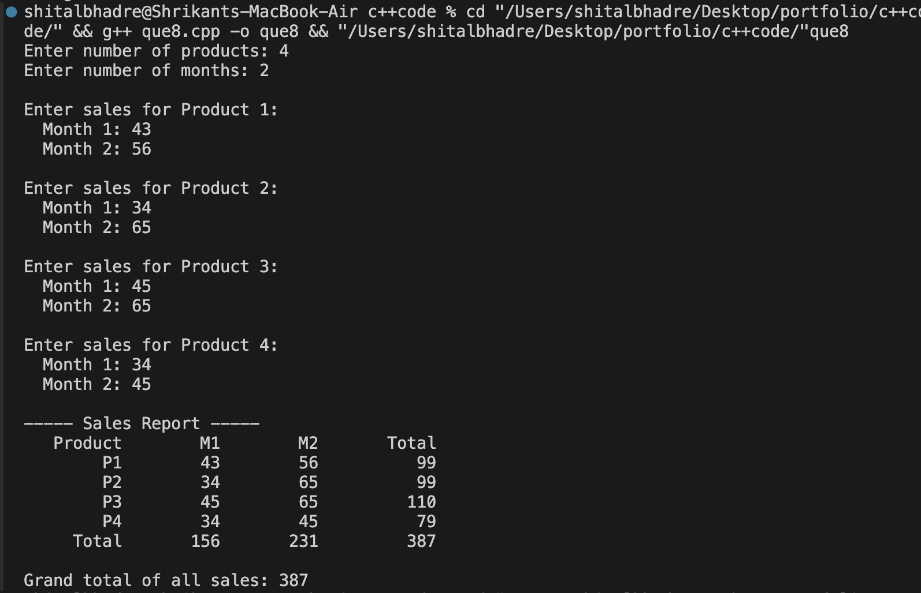

ID:7
Shital Digambar Bhadre.
Reg No:260640160611
Utkarsha Subhash Pawar.
Reg No:260640160985

Assignment 2

Q1.Inline Function
Write a C++ program to create an inline function that calculates the square of a number. Accept the number from the user and display the square.

#include<iostream>
using namespace std;
inline int Square(int x){
return x*x;
}
int main()
{
int x;
cout<<"Enter num:";
cin>>x;
int square=Square(x);
cout<<"Square of num:"<<square;
}

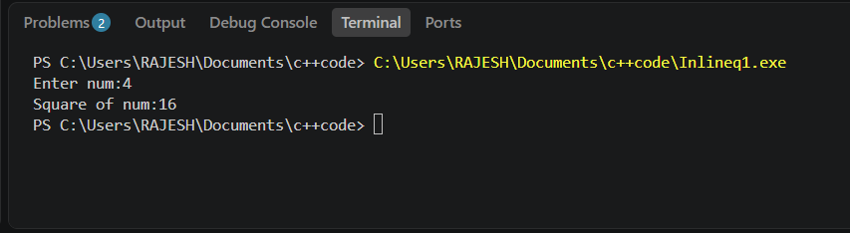

Q2 Recursive Function
Write a C++ program to find the factorial of a given number using a recursive function.

#include<iostream>
using namespace std;
int factorial(int n)
{
if (n>1){
return n*factorial(n-1);
}
else{
return 1;
}

}
int main()
{
cout<<"Factorial of 5 is: "<<factorial(5);
return 0;
}

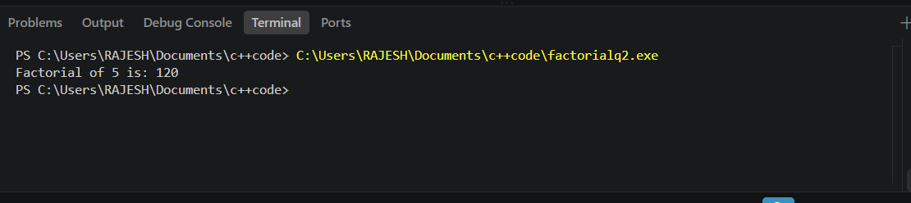

Q3.Recursive Function
Write a C++ program to print the first N Fibonacci numbers using recursion.

#include<iostream>
using namespace std;
int fibo(int n){
if(n==0){
return 0;
}
if(n==1)
{
return 1;
}
return fibo(n-1) + fibo(n-2);
}
int main()
{
int n;
cout<<"\n Enter n:";
cin>>n;
for(int i=0;i<n;i++)
cout<<"\t"<<fibo(i);
return 0;
}

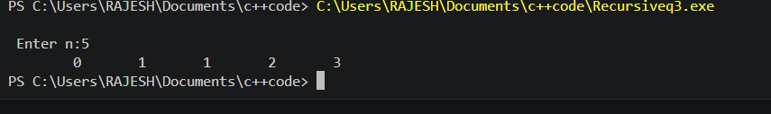

Q4.Recursive Function
Write a C++ program to calculate the sum of digits of a given number using recursion.

#include<iostream>
using namespace std;
int sum(int n) {
int rem = n %10;
n = n/10;

if(n==0){
return rem;
}
else{
return rem + sum(n);
}

}
int main()
{
int n;
cout<<"Enter number: ";
cin >> n;
int Sum = sum(n);
cout<<"sum is: "<<Sum;
return 0;

}

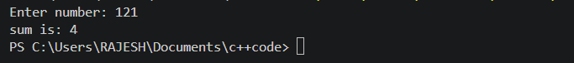

Q5.Function Overloading
#include <iostream>
using namespace std;

class AreaCalculator
{
public:
// Function to calculate area of a circle
void Area(int r)
{
float area = 3.14 * r * r;
cout << "Area of Circle = " << area << endl;
}

// Function to calculate area of a rectangle
void Area(int length, int breadth)
{
int area = length * breadth;
cout << "Area of Rectangle = " << area << endl;
}
};

int main()
{
AreaCalculator obj;

obj.Area(7);
obj.Area(10, 5);

return 0;
}

Output:
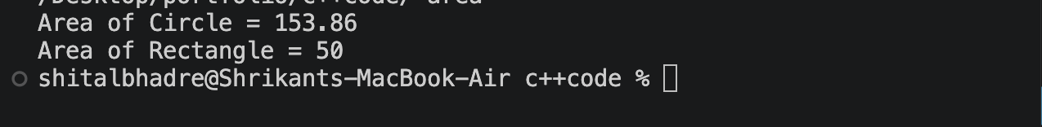
Q7.Pass by Reference
Accept two numbers from user pass these numbers to Swap function, Function should interchange the values

#include<iostream>
using namespace std;
void swap(int &p,int &q){
int temp;
temp = p;
p=q;
q=temp;
}
int main(){
int a,b;
cout<<"Enter Numbers:";
cin>>a>>b;

swap(a,b);
cout<<"After swapping: "<<a<<"\t"<<b;
return 0;
}

Q8. Default Function Arguments
Write a C++ program to calculate simple interest using a function with default arguments.
Use the default rate of interest as 8%.
calculateSI(principal, years)
calculateSI(principal, years, rate)

#include<iostream>
using namespace std;
void Simple(double P,float T,float R=8)
{
cout<<"Simple Interest: "<<(P*R*T)/100;
}
int main()
{
Simple(10,20);
cout<<endl;
Simple(5000,3,12);
return 0;
}

Q9.variable parameter
Write a C++ program using a variable parameter list to calculate the sum of any number of integers.
sum(3,10,20,30)
sum(5,2,4,6,8,10

#include<iostream>
#include<cstdarg>
using namespace std;
int sum (int count , ... )
{
va_list args;
va_start (args,count);
int total=0;
for(int i=0;i<count;i++)
{
total += va_arg(args,int);
}
va_end(args);

return total;
}
int main(){
cout<<"sum ="<<sum(3,10,20,30)<<endl;
cout<<"sum="<<sum(5,2,4,6,8,10)<<endl;
return 0;
}

Assignment No .3

Q1Implement Date class with following
Data members
day,month,year
Member functions
accept function
display function
overload display function. pass character value which is separator for day,month and year
CheckLeapYear function

#include<iostream>
using namespace std;
class Date
{
private:
int day,month,year;
public:
void display()
{
cout<<"\n\tDate:"<<day<<"/"<<month<<"/"<<year<<endl;

}
void setDate(int d,int m,int y){
day=d;
month=m;
year=y;

}
bool checkleapyear(){
if(year % 4 == 0){
if(year % 100 ==0){
return year % 400 == 0;
}
return true;
}
return false;
}
};
int main(){
Date D;
D.setDate(7,6,2026);
D.display();
if(D.checkleapyear()){
cout<<"leap year"<<endl;
}
else{
cout<<"Not leap year"<<endl;
}
return 0;
}

Q2.Implement Complex class with following
Data members
real,img
Member function
accept function
display function
AddComplexNumbers

#include<iostream>
using namespace std;
class complex
{
private:
int rel , img ;
public:
void Accept(){
cout<<"Enter real number: ";
cin>>rel;
cout<<"Enter img number: ";
cin>>img;

}
void display(){
cout<<"Complex Number: "<<rel<<"+"<<img<<"i"<<endl;
}
void complexnumber(complex C1,complex C2){
rel = C1.rel + C2.rel;
img = C1.img + C2.img;

}
};
int main()
{
complex C1,C2,C3;
C1.Accept();
C2.Accept();
C3.complexnumber(C1,C2);
C1.display();
C2.display();
C3.display();

return 0;
}

Q3.Library Management
Create a LibraryBook class containing:
Book ID
Book Name
Author Name
Price
Implement:
Accept function
Display function
give 10% discount to very book

#include <iostream>
using namespace std;

class LibraryBook
{
private:
int bookID;
string bookName;
string authorName;
float price;
float discountedPrice;
public:
void Accept()
{
cout << "Enter Book ID: ";
cin >> bookID;
cout << "Enter Book Name: ";
cin>>bookName;
cout << "Enter Author Name: ";
cin>>authorName;

cout << "Enter Price: ";
cin >> price;
discountedPrice = price - (price * 0.10);
}

void Display()
{
cout << "Book ID : " << bookID << endl;
cout << "Book Name : " << bookName << endl;
cout << "Author Name : " << authorName << endl;
cout << "Original Price: " << price << endl;
cout << "Discount : 10%" << endl;
cout << "Final Price : " << discountedPrice << endl;
}
};
int main()
{
LibraryBook book;
book.Accept();
book.Display();
return 0;
}

Q4.Create box class
Data members
length, width, height;
Implement:
Accept function
Display function
Calculate volume() function

#include<iostream>
using namespace std;
class Box{
private:
int h,w,l;
public:
void Accept(){
cout<<"Enter height,weight,length: \n";
cin>>h>>w>>l;

}
void Display(){
cout<<h<<w<<l<<endl;
}
void calculate(){
int cal=h*w*l;
cout<<cal<<endl;
}
};
int main(){
Box B;
B.Accept();
B.Display();
B.calculate();
return 0;
}

Shital Digambar Bhadre
PRN:260740150022
Utkarsha Subhash Pawar
PRN :260740150028

Assignment 4

1. Employee and Address
Problem Statement:
Create an Employee class that contains an object of an Address class representing the employee's residential address. The Address class should contain area,city, and PIN code. Accept and display the complete employee and address details.implement constructors.
#include<iostream>
using namespace std;

class Address
{
string area, city;
int pincode;
public:
Address()
{
cout << "Enter area: ";
cin >> area;
cout << "Enter city: ";
cin >> city;
cout << "Enter pincode: ";
cin >> pincode;
}
void display()
{
cout << "Area: " << area << endl;
cout << "City: " << city << endl;
cout << "Pincode: " << pincode << endl;
}
};

class employee{
int eid;
string ename;
Address addr;
public:
employee(){
cout << "Enter id: ";
cin >> eid;
cout << "Enter name: ";
cin >> ename;
}
void display(){
cout << "Employee id: " << eid << endl;
cout << "Employee name: " << ename << endl;
addr.display();
}
};

int main(){
employee e;
e.display();
return 0;
}

Output:
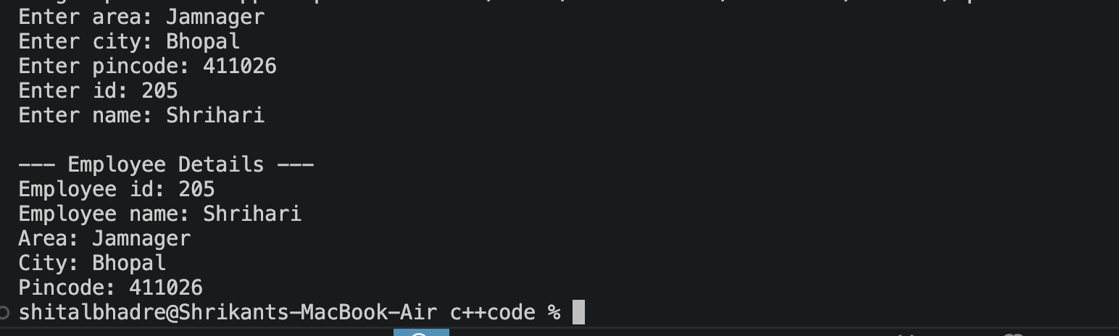

Concept: Object of one class as a data member of another class.
2. Book and Publisher
Problem Statement:
Create a Book class that contains an object of a Publisher class representing the publisher details. The Publisher class should contain publisher name, city, and contact number. Accept and display the book details along with its publisher information.
#include<iostream>
using namespace std;

class Publisher
{
string pname, city;
long contactNo;
public:
Publisher()
{
cout << "Enter publisher name: "<<endl;
cin >> pname;
cout << "Enter city: "<<endl;
cin >> city;
cout << "Enter contact number: "<<endl;
cin >> contactNo;
}
void display()
{
cout << "Publisher Name : " << pname << endl;
cout << "City : " << city << endl;
cout << "Contact Number : " << contactNo << endl;
}
};

class Book{
string title;
string author;
float price;
Publisher pub;

public:
Book(){
cout << "Enter book title: ";
cin >> title;
cout << "Enter author name: ";
cin >> author;
cout << "Enter price: ";
cin >> price;

}
void display(){
cout << "\n--- Book Details ---" << endl;
cout << "Title : " << title << endl;
cout << "Author : " << author << endl;
cout << "Price : " << price << endl;
cout << "\n--- Publisher Details ---" << endl;
pub.display();
}
};

int main(){
Book b;
b.display();
return 0;
}

Output:
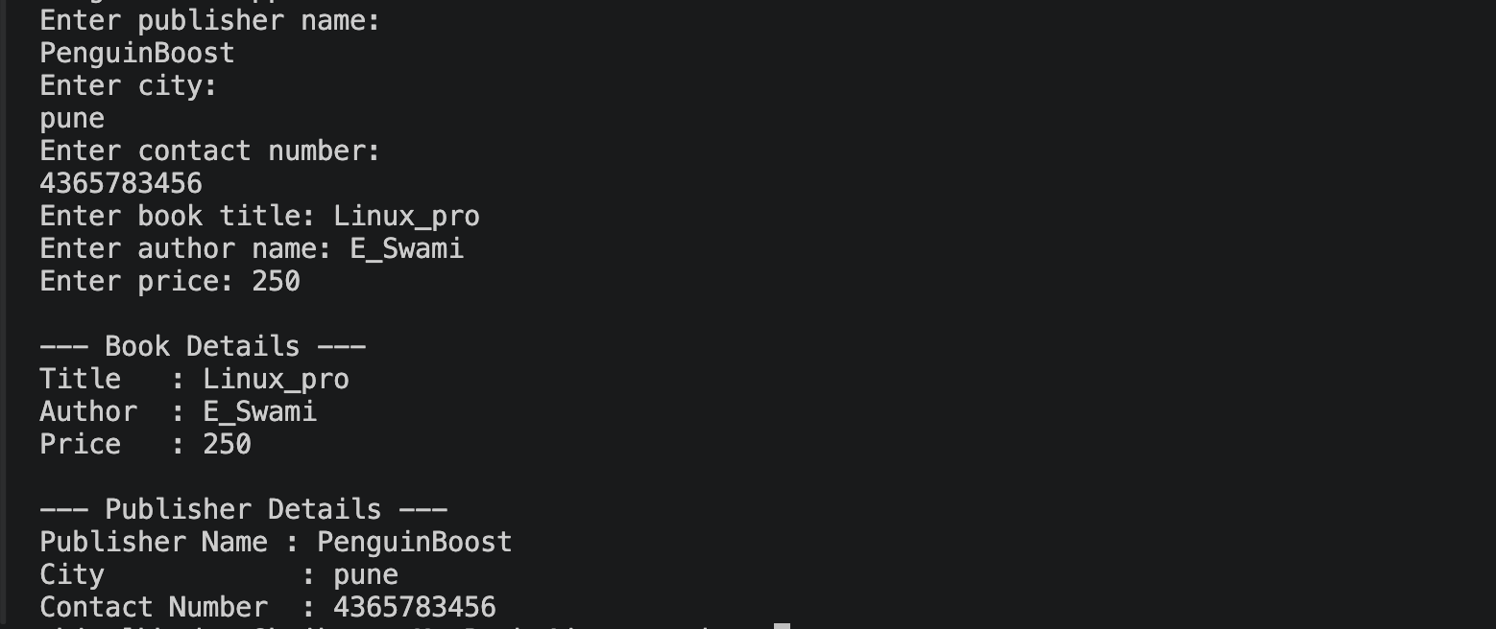

Concept: Composition between Book and Publisher.
3.Employee and Joining Date
Problem Statement:
Create an Employee class that contains an object of a Date class representing the employee's joining date. The Date class should contain day, month, and year. Accept employee ID, employee name, salary, and joining date, and display all the details.
Concept: Employee has-a Date.
#include<iostream>
using namespace std;

class Date
{
int day, month, year;
public:
Date()
{
cout << "Enter day: ";
cin >> day;
cout << "Enter month: ";
cin >> month;
cout << "Enter year: ";
cin >> year;
}
void display()
{
cout << day << "/" << month << "/" << year << endl;
}
};

class Employee{
int eid;
string ename;
float salary;
Date joiningDate;
public:
Employee(){
cout << "Enter employee id: ";
cin >> eid;
cout << "Enter employee name: ";
cin >> ename;
cout << "Enter salary: ";
cin >> salary;
}
void display(){
cout << "\n--- Employee Details ---" << endl;
cout << "Employee ID : " << eid << endl;
cout << "Employee Name : " << ename << endl;
cout << "Salary : " << salary << endl;
cout << "Joining Date : ";
joiningDate.display();
}
};

int main(){
Employee e;
e.display();
return 0;
}

Output:
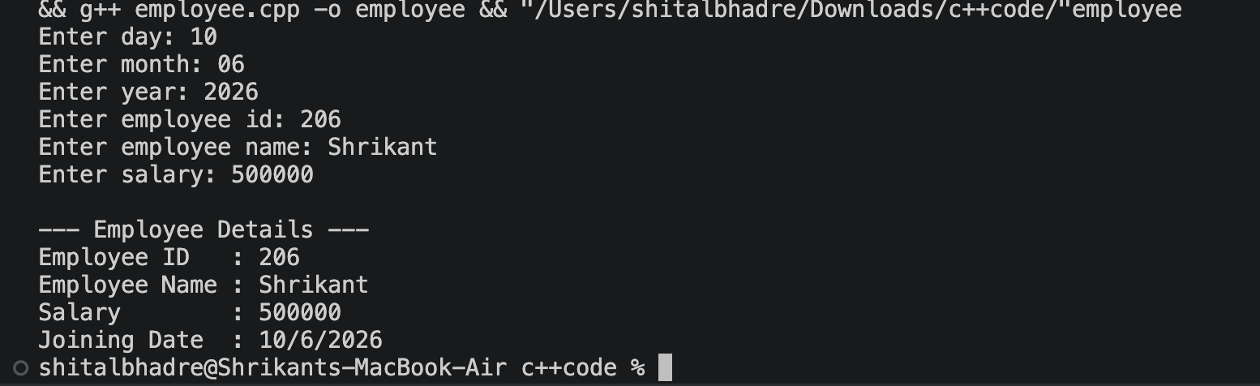

4. Customer and Contact Details
Problem Statement:
Create a Customer class that contains an object of a Contact class representing the customer's contact information. The Contact class should contain mobile number, email address, and city. Accept and display the customer details along with contact information.
Concept: Composition using a Contact object.
#include<iostream>
using namespace std;

class Contact
{
long mobileNo;
string email, city;
public:
Contact()
{
cout << "Enter mobile number: ";
cin >> mobileNo;
cout << "Enter email address: ";
cin >> email;
cout << "Enter city: ";
cin >> city;
}
void display()
{
cout << "Mobile Number : " << mobileNo << endl;
cout << "Email Address : " << email << endl;
cout << "City : " << city << endl;
}
};

class Customer{
int custId;
string custName;
Contact contact; // Contact class ka OBJECT — "Composition using a Contact object"

public:
Customer(){
cout << "Enter customer id: ";
cin >> custId;
cout << "Enter customer name: ";
cin >> custName;
// contact ka constructor is se pehle hi chal chuka hoga (member object)
}
void display(){
cout << "\n--- Customer Details ---" << endl;
cout << "Customer ID : " << custId << endl;
cout << "Customer Name : " << custName << endl;
cout << "\n--- Contact Details ---" << endl;
contact.display();
}
};

int main(){
Customer c;
c.display();
return 0;
}

Output:
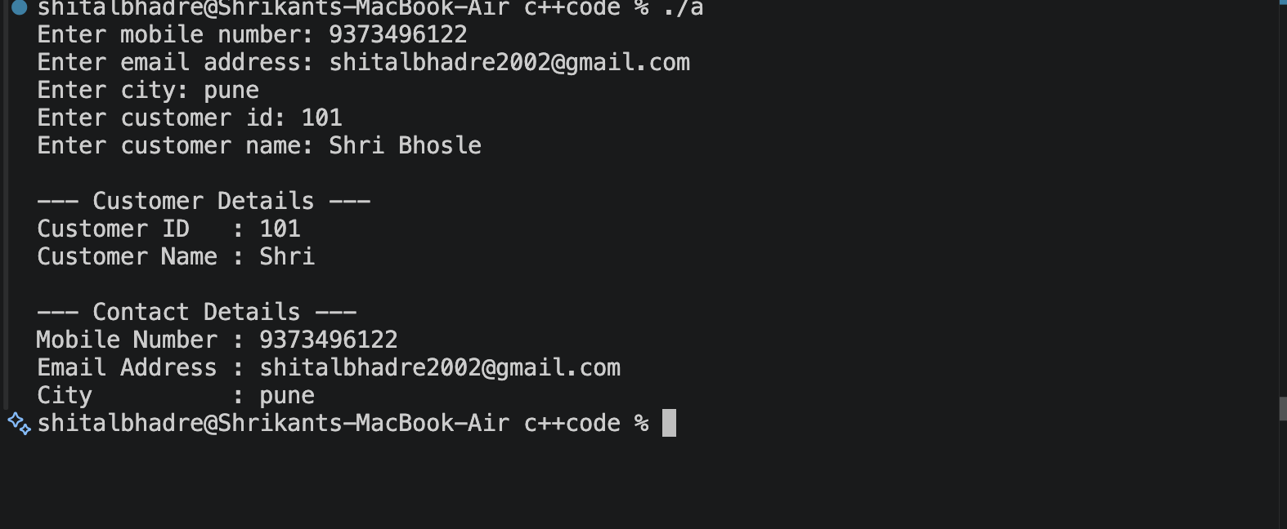

5. Vehicle and Engine
Problem Statement:
Create a Vehicle class that contains an object of an Engine class representing the vehicle's engine details. The Engine class should contain engine number, engine type, and engine capacity. Accept and display the complete vehicle and engine details.
Concept: Vehicle has-a Engine.
#include<iostream>
using namespace std;

class Engine
{
string engineNo, engineType;
float capacity;
public:
Engine()
{
cout << "Enter engine number: ";
cin >> engineNo;
cout << "Enter engine type: ";
cin >> engineType;
cout << "Enter engine capacity (in cc/litres): ";
cin >> capacity;
}
void display()
{
cout << "Engine Number : " << engineNo << endl;
cout << "Engine Type : " << engineType << endl;
cout << "Engine Capacity : " << capacity << endl;
}
};

class Vehicle{
string vehicleName;
string model;
Engine engine; // Engine class ka OBJECT — "Vehicle has-a Engine"

public:
Vehicle(){
cout << "Enter vehicle name: ";
cin >> vehicleName;
cout << "Enter model: ";
cin >> model;
// engine ka constructor is se pehle hi chal chuka hoga (member object)
}
void display(){
cout << "\n--- Vehicle Details ---" << endl;
cout << "Vehicle Name : " << vehicleName << endl;
cout << "Model : " << model << endl;
cout << "\n--- Engine Details ---" << endl;
engine.display();
}
};

int main(){
Vehicle v;
v.display();
return 0;
}

Output:
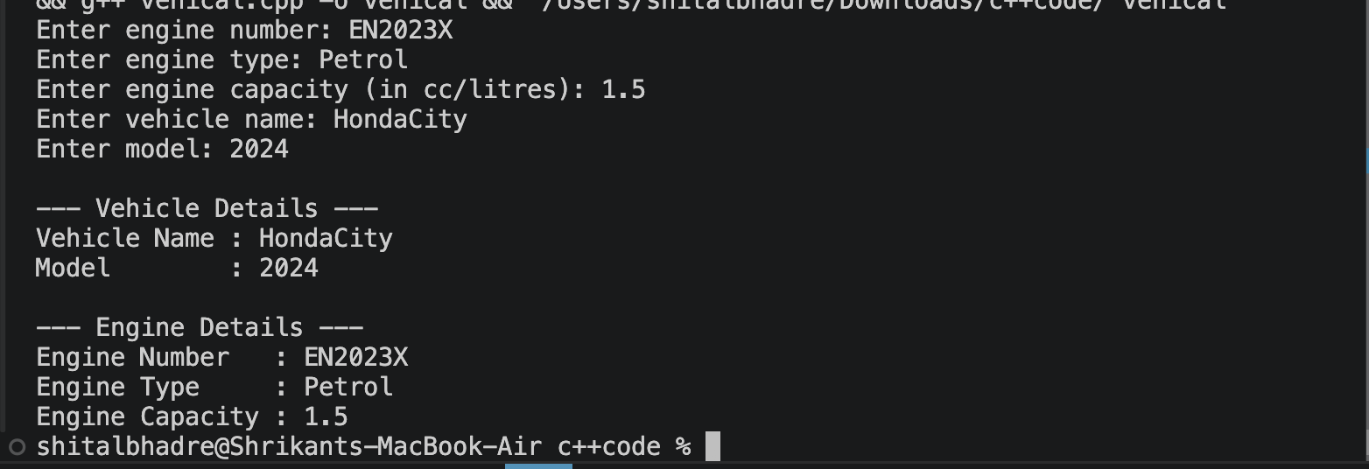

Shital Digambar Bhadre
PRN:260740150022
Utkarsha Subhash Pawar
PRN :260740150028

Assignment 5:
1. Program 1: Complex Number – Operator Overloading
Problem Statement:
Create a Complex class to represent complex numbers using real and imaginary parts. Overload the following operators to perform the corresponding operations on two complex number objects:

+ – Addition of two complex numbers
- – Subtraction of two complex numbers
++ – Pre Increment the real and imaginary parts of a complex number
++ – PostIncrement the real and imaginary parts of a complex number
<< and >> operator
Create appropriate objects and demonstrate the working of all the overloaded operators.

#include<iostream>
using namespace std;
class Complex {
private:
int real, img;
public:
Complex() {
this->real = this->img = 1;
}
Complex(int real, int img) {
this->real = real;
this->img = img;
}

Complex operator+(Complex &c) {
Complex temp;
temp.real = real + c.real;
temp.img = img + c.img;
return temp;

}
Complex operator-(Complex &c) {
Complex temp;
temp.real = real - c.real;
temp.img = img - c.img;
return temp;
}
Complex operator++(int a) {
Complex temp;
temp.real = this->real++;
temp.img = this->img++;
return temp;
}
Complex operator--(int b) {
Complex temp;
temp.real = this->real--;
temp.img = this->img--;
return temp;
}
friend ostream& operator<<(ostream &out, Complex &c)
{
out << c.real << " + " << c.img << "i";
return out;
}

friend istream& operator>>(istream &in, Complex &c)
{
cout << "Enter real part: ";
in >> c.real;

cout << "Enter imaginary part: ";
in >> c.img;
return in;
}
void Display() {
cout << "\n\n\t Complex : " << this->real << "+" << img << "i";
}
};
int main() {
{
Complex c1(10, 20);
Complex c2(2, 5);
Complex c3;

c3 = c1 + c2;

cout << "\n\t --------Complex operator+(Complex &c)------";
c1.Display();
c2.Display();
c3.Display();
}
{
Complex c1(10, 20);
Complex c2(2, 5);
Complex c3;

c3 = c1 - c2;

cout << "\n\t --------Complex operator-(Complex &d)------";
c3.Display();
}
{
Complex c1(10, 20);
Complex c3;

c3 = c1++;

cout << "\n\t *********Complex operator++()*****";
c1.Display();
c3.Display();
}
{
Complex c1(10, 20);
Complex c3;

c3 = c1--;

cout << "\n\t --------Complex operator--()------";
c1.Display();
c3.Display();
}
{
Complex c1(2,3);
cout << "\n\t --------Complex operator>>()-----";
cin>>c1;
cout<<c1;
}
{
Complex c1(10,20);
cout << "\n\t --------Complex operator<<()-----";
cout<<c1;
}
return 0;

}

Output:
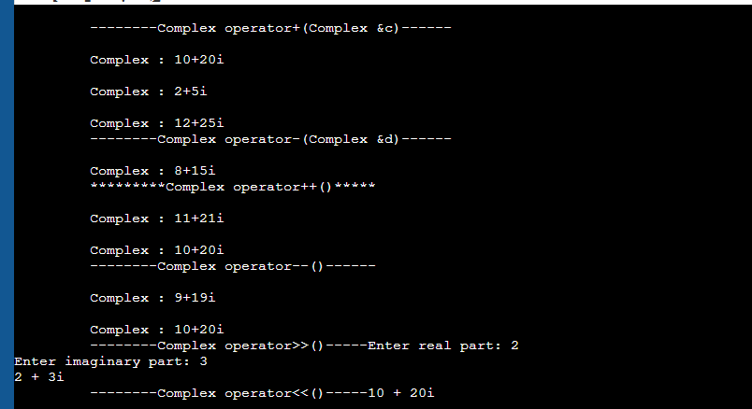

2. Program 2: Box – Relational Operator Overloading
Problem Statement:
Create a Box class with data members length, width, and height. Define a member function to calculate the volume of a box. Overload the > operator to compare two Box objects based on their volumes. Display
which box has the greater volume.

#include <iostream>
using namespace std;

class Box {
float length, width, height;

public:

Box(float l, float w, float h) {
length = l;
width = w;
height = h;
}

float volume() {
return length * width * height;
}

bool operator>(Box b) {
return volume() > b.volume();
}
};

int main() {
Box box1(10, 5, 4);
Box box2(8, 6, 3);

if (box1 > box2)
cout << "Box 1 has greater volume." << endl;

else if (box2 > box1)
cout << "Box 2 has greater volume." << endl;

else
cout << "Both boxes have equal volume." << endl;

cout << "Volume of Box 1 = " << box1.volume() << endl;
cout << "Volume of Box 2 = " << box2.volume() << endl;

return 0;
}

Output
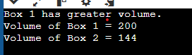

3. Create Array class Implement following.
Accept and Display function
Operator + for adding two arrays.
implement copy constructor.
implement destructor.
overload > operator.

#include<iostream>
using namespace std;

class Array {
int size;
int* arr;
public:
Array() {
size = 3;
arr = new int[size];
}
Array(int s)
{
size = s;
arr = new int[size];
}
void Accept()
{
cout << "\n\t Enter " << size << " Elements ";
for (int i = 0; i < size; i++)
cin >> arr[i];
}
void Display() {
cout << "\n\n\t Array Is \n";
for (int i = 0; i < size; i++)
cout << arr[i] << " ";
}

Array operator+(Array& obj) {
Array temp;
temp.size = this->size + obj.size;
temp.arr = new int[temp.size];
int j = 0;
for (int i = 0; i < this->size; i++)
temp.arr[j++] = this->arr[i];
for (int i = 0; i < obj.size; i++)
temp.arr[j++] = obj.arr[i];
return temp;

}
Array(const Array& obj) {
size = obj.size;
arr = new int[size];
for (int i = 0; i < obj.size; i++)
arr[i] = obj.arr[i];
}
~Array()
{
delete[]arr;

}
};
int main()
{
Array a1(4);
a1.Accept();

Array a2(3);
a2.Accept();

a1.Display();
a2.Display();

Array a3 = a1;
a3.Display();

Array a4(a1);
a4.Display();

}

Output
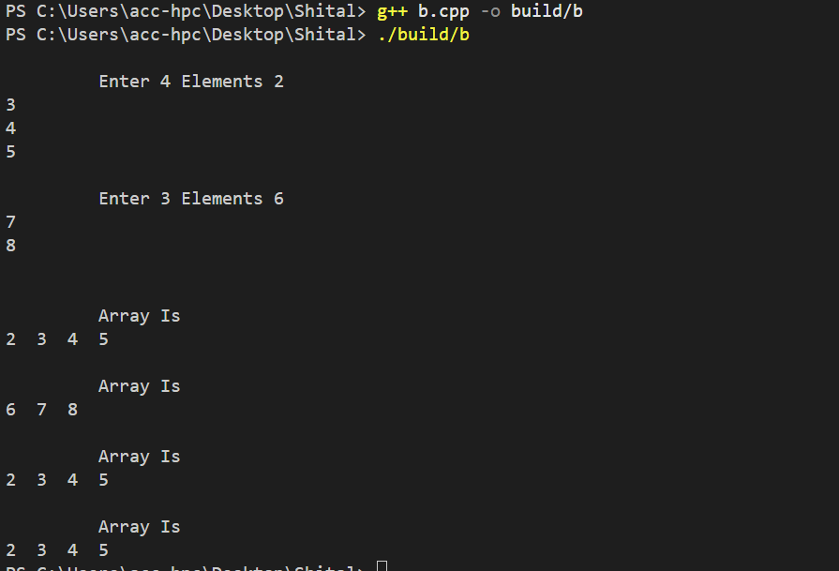

4. Create circle class with data member pi and redius.
1.Declare pi as const data member
2.implement display and getRedius function as const function
3. create const object and invoke all functions.

#include<iostream>
using namespace std;
class circle{
int red;
const float pi=3.14;
public:
circle(int r=2){
red=r;

}
void display()const{
cout<<"redius:"<<red<<endl;
cout<<"Area:"<<(pi * red * red )<<endl;
}
void getRadius()const {
cout<<red;

}
};
int main(){

const circle C1(5);
C1.display();
C1.getRadius();
return 0;
}

Output
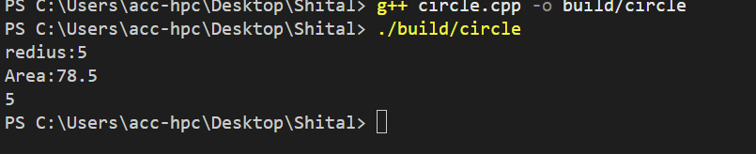

5. create class Person (age, name)
inherite person class and create student class with data member rno,and percentage.
create appropriate objects and invoke functions.

#include<iostream>
using namespace std;
class Person {
int age;
string name;
public:
Person() {
age = 22;
name = "priya";

}
Person( string name, int age) {
this->age = age;
this->name = name;
}
void Display() {

cout << "\n\tName : " << name;
cout << "\n\t Age: " << age<<endl;
}
};
class student :public Person
{
int rollno;
float per;
public:
student() {
rollno = 0;
per = 0;
}
student(int rollno, string name, int age, float per):Person(name,age) {
this->rollno = rollno;
this->per = per;
}
void Display() {

cout << "\n\t rollno " << rollno;
Person::Display();
cout << "\n\t percentage : " << per;
}

};

int main()
{
Person p1;
p1.Display();

student s1;

cout<<"Student Details"<<endl;
s1.Display();
student s2(106, "seeta", 25, 80);
s2.Display();

cout << "\n\n\n";
}

Output
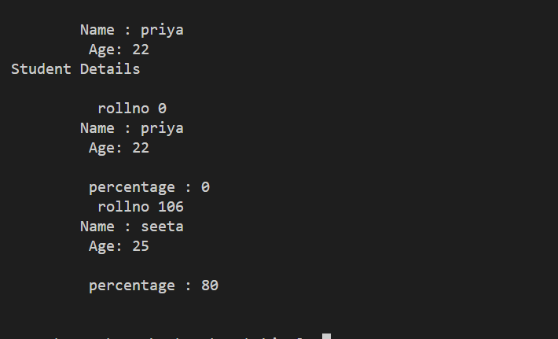

ID NO:7
Shital Digambar Bhadre
PRN NO:260740150022
Utkarsha Shubhash Pawar
PRN NO:260740150028

Assignment 6:
1.Create a base class Shape and derive three classes Circle, Rectangle, and Triangle from it. Implement the area() function using run-time polymorphism.
Base Class: Shape
Data Members:
string shapeName
Member Functions:
void acceptShapeName()
void displayShapeName()
virtual void area()
Derived Class: Circle
Data Members:
float radius
Member Functions:
void accept()
void area() — calculate and display the area of the circle.
Formula:
Area = π × radius × radius
Derived Class: Rectangle
Data Members:
float length
float width
Member Functions:
void accept()
void area() — calculate and display the area of the rectangle.
Formula:
Area = length × width
Derived Class: Triangle
Data Members:
float base
float height
Member Functions:
void accept()
void area() — calculate and display the area of the triangle.
Formula:
Area = 0.5 × base × height
Requirements
Use inheritance to derive the three classes from Shape.
Declare area() as a virtual function in the base class.
Override area() in every derived class.
Create a Shape* pointer.
Assign the address of each derived-class object to the base-class pointer.
Call area() through the base-class pointer to demonstrate run-time polymorphism.

Output:

Using Array:
#include <iostream>
#include <cmath>
using namespace std;

class Shape {
public:
virtual void accept() = 0;
virtual void display() = 0;
virtual double calculateArea() = 0;
virtual ~Shape() {}
};

class Circle : public Shape {
double radius;
public:
void accept() override {
cout << "Enter radius of Circle: ";
cin >> radius;
}
void display() override {
cout << "Circle with radius = " << radius << endl;
}
double calculateArea() override {
return M_PI * radius * radius;
}
};

class Rectangle : public Shape {
double length, breadth;
public:
void accept() override {
cout << "Enter length and breadth of Rectangle: ";
cin >> length >> breadth;
}
void display() override {
cout << "Rectangle with length = " << length
<< " and breadth = " << breadth << endl;
}
double calculateArea() override {
return length * breadth;
}
};

class Triangle : public Shape {
double base, height;
public:
void accept() override {
cout << "Enter base and height of Triangle: ";
cin >> base >> height;
}
void display() override {
cout << "Triangle with base = " << base
<< " and height = " << height << endl;
}
double calculateArea() override {
return 0.5 * base * height;
}
};

int main() {
Shape* shapes[10];
int choice, count = 0;

do {
cout << "\nMenu:\n";
cout << "1. Circle\n";
cout << "2. Rectangle\n";
cout << "3. Triangle\n";
cout << "4. Display all shapes and areas\n";
cout << "5. Exit\n";
cout << "Enter your choice: ";
cin >> choice;

switch(choice) {
case 1:
shapes[count] = new Circle();
shapes[count]->accept();
count++;
break;
case 2:
shapes[count] = new Rectangle();
shapes[count]->accept();
count++;
break;
case 3:
shapes[count] = new Triangle();
shapes[count]->accept();
count++;
break;
case 4:
for (int i = 0; i < count; i++) {
shapes[i]->display();
cout << "Area = " << shapes[i]->calculateArea() << endl;
}
break;
case 5:
cout << "Exiting program..." << endl;
break;
default:
cout << "Invalid choice!" << endl;
}
} while(choice != 5);

for (int i = 0; i < count; i++) {
delete shapes[i];
}

return 0;
}

Output:
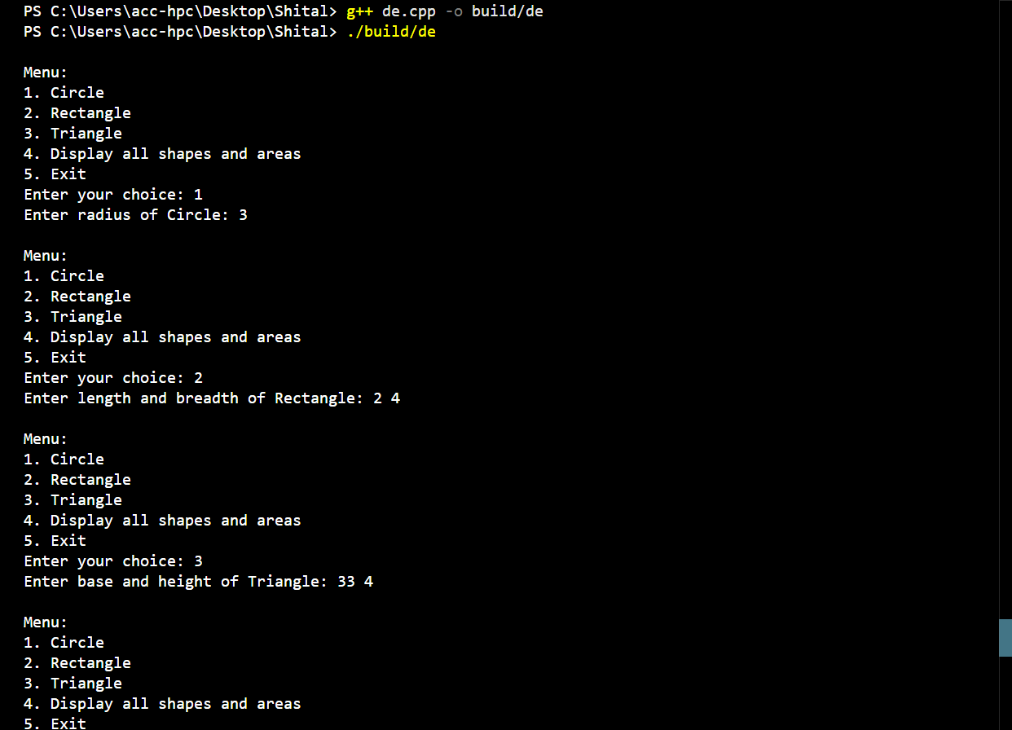
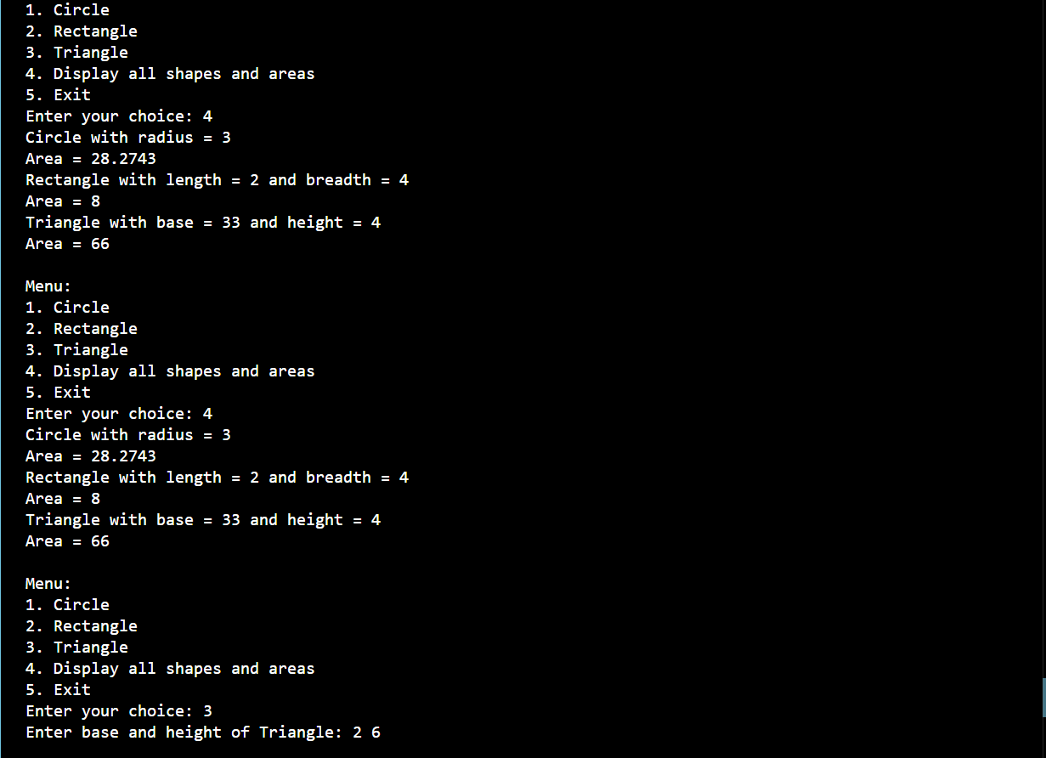

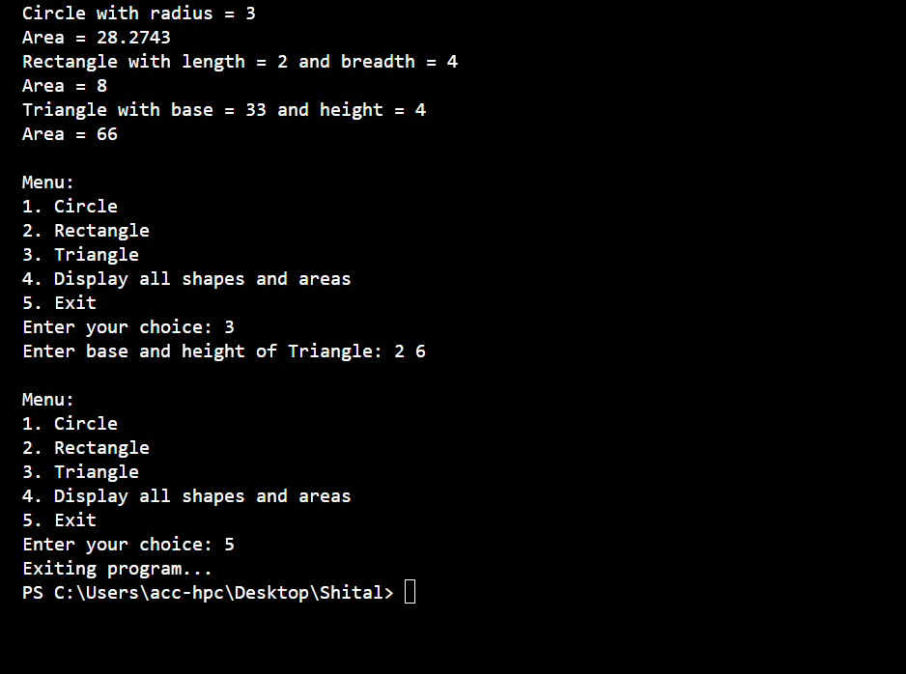
Q1.without Array:
#include <iostream>
#include <string>
using namespace std;
class shape {
private:
string shapename;
public:
void acceptShapeName() {
cout << "Shape Name: ";
cin >> shapename;
}

void displayShapeName() {
cout << "Shape Name: " << shapename << endl;
}

virtual void area() = 0;
virtual ~shape() {}
};

class Circle : public shape {
private:
float radius;
float calculatedArea;

public:
void Accept() {
cout << "Enter radius: ";
cin >> radius;
}

void area() override {
calculatedArea = 3.14* radius * radius;
}

void display() {
cout << "Area is: " << calculatedArea << endl;
}
};

class rectangle : public shape {
private:
float len, width;

public:
void Accept() {
cout << "Enter length and width: ";
cin >> len >> width;
}

void area() override {
float rectArea = len * width;
cout << "Area of rectangle: " << rectArea << endl;
}
};

class triangle : public shape {
private:
float base, height;

public:
void Accept() {
cout << "Enter Base and Height: ";
cin >> base >> height;
}

void area() override {
float triArea = 0.5f * base * height;
cout << "Area of Triangle: " << triArea << endl;
}
};

int main() {
int choice;

cout << "\n\t Choose a shape:\n";
cout << "\t 1. Circle\n";
cout << "\t 2. Rectangle\n";
cout << "\t 3. Triangle\n";
cout << "\t Enter choice (1-3): ";
cin >> choice;

switch (choice) {
case 1: {
Circle C1;
C1.Accept();
C1.area();
C1.display();
break;
}
case 2: {
rectangle R1;
R1.Accept();
R1.area();
break;
}
case 3: {
triangle T1;
T1.Accept();
T1.area();
break;
}
default:
cout << "\n\t Invalid choice." << endl;
break;
}

return 0;
}

Output:
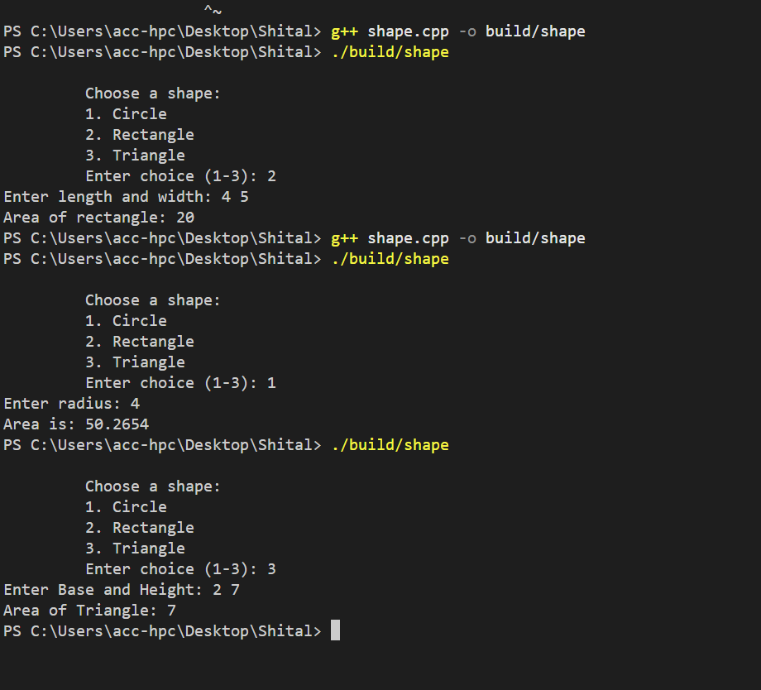
Q2:
Question 2: Employee Salary Using Run-Time Polymorphism
Create a base class Employee and derive Manager, Developer, and SalesEmployee classes from it. Calculate the salary of each employee using function overriding and run-time polymorphism.
Base Class: Employee
Data Members:
int employeeId
string employeeName
double basicSalary
Member Functions:
void accept()
void display()
virtual double calculateSalary()
Derived Class: Manager
Data Members:
double allowance
Member Functions:
void accept()
double calculateSalary()
Formula:
Salary = Basic Salary + Allowance
Derived Class: Developer
Data Members:
double bonus
Member Functions:
void accept()
double calculateSalary()
Formula:
Salary = Basic Salary + Bonus
Derived Class: SalesEmployee
Data Members:
double salesAmount
double commissionRate
Member Functions:
void accept()
double calculateSalary()
Formula:
Salary = Basic Salary + (salesAmount*commissionRate)
Requirements
Create an Employee* base-class pointer.
Create objects of Manager, Developer, and SalesEmployee.
Store the address of each derived object in the base-class pointer.
Invoke calculateSalary() using the base-class pointer.
Demonstrate run-time polymorphism.

#include <iostream>
#include <string>
using namespace std;
class employee {
private:
int eid;
string ename;
protected:
double salary;
public:
virtual void Accept() {
cout << "Enter emp id, name, salary: ";
cin >> eid >> ename >> salary;
}
virtual void display() {
cout << "\nEmployee ID: " << eid;
cout << "\nEmployee Name: " << ename;
cout << "\nBase Salary: " << salary << endl;
}
virtual double calculatesal() = 0;
virtual ~employee() {}
};
class manager : public employee {
private:
double allowance;
public:
void Accept() override {
employee::Accept();
cout << "Enter Allowance: ";
cin >> allowance;
}
double calculatesal() override {
return salary + allowance;
}
void display() override {
employee::display();
cout << "Total Salary : " << calculatesal() << endl;
}
};
class developer : public employee {
private:
double bonus;
public:
void Accept() override {
employee::Accept();
cout << "Enter Bonus: ";
cin >> bonus;
}

double calculatesal() override {
return salary + bonus;
}

void display() override {
employee::display();
cout << "Total Salary : " << calculatesal() << endl;
}
};
class salesemp : public employee {
private:
double salesAmount;
double commRate;
public:
void Accept() override {
employee::Accept();
cout << "Enter Sales Amount: ";
cin >> salesAmount;
cout << "Enter Commission Rate : ";
cin >> commRate;
}
double calculatesal() override {
return salary + (salesAmount * commRate);
}
void display() override {
employee::display();
cout << "Total Salary : " << calculatesal() << endl;
}
};
int main() {
employee* emp[10];
int choice, count = 0;
do {
cout << "\nMenu:\n";
cout << "1. Manager\n";
cout << "2. Developer\n";
cout << "3. Sales Employee\n";
cout << "4. Display all employees and salaries\n";
cout << "5. Exit\n";
cout << "Enter your choice: ";
cin >> choice;

switch (choice) {
case 1:
emp[count] = new manager();
emp[count]->Accept();
count++;
break;
case 2:
emp[count] = new developer();
emp[count]->Accept();
count++;
break;
case 3:
emp[count] = new salesemp();
emp[count]->Accept();
count++;
break;
case 4:
for (int i = 0; i < count; i++) {
emp[i]->display();
}
break;
case 5:
cout << "Exiting program..." << endl;
break;
default:
cout << "Invalid choice!" << endl;
}
} while (choice != 5);

for (int i = 0; i < count; i++) {
delete emp[i];
}

return 0;
}

Output:

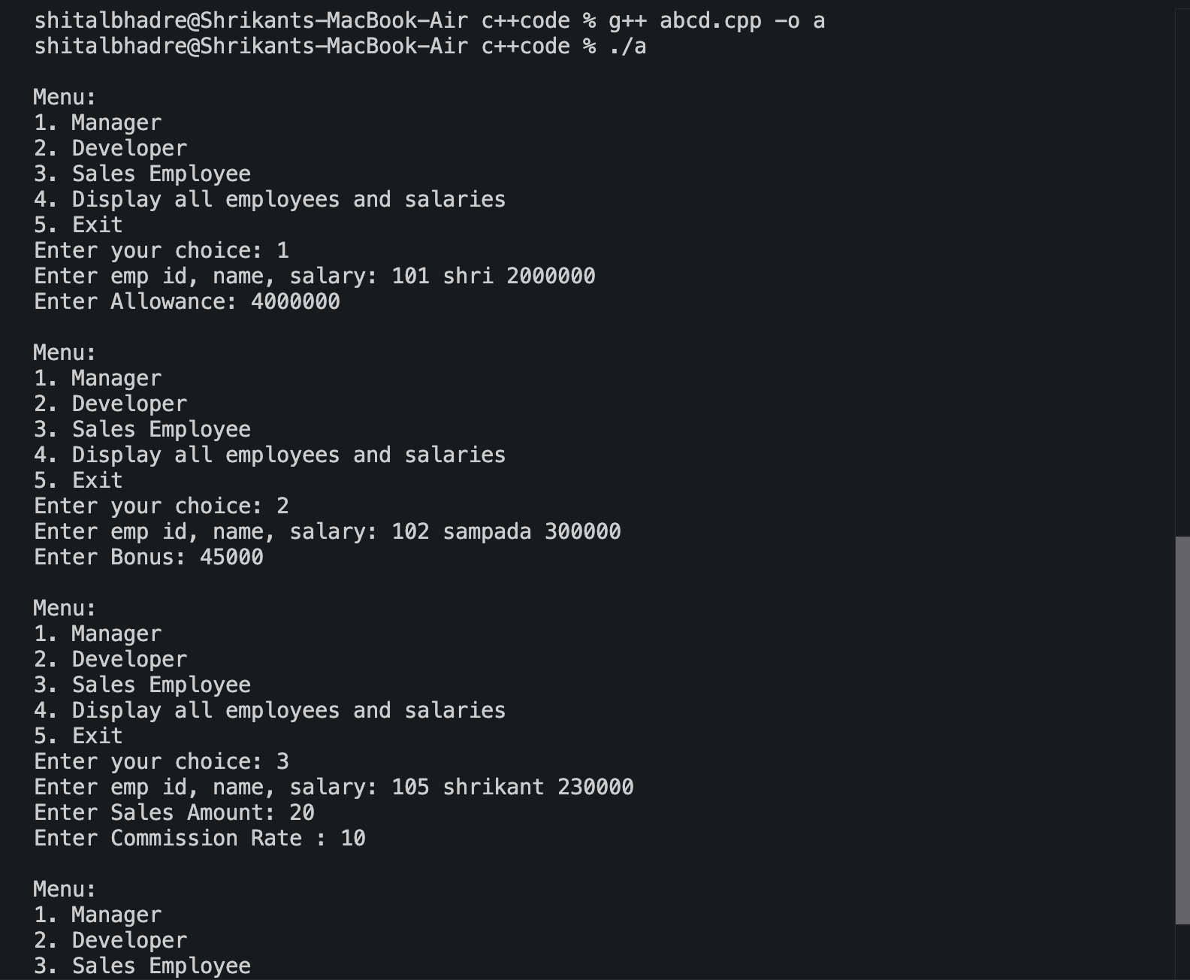

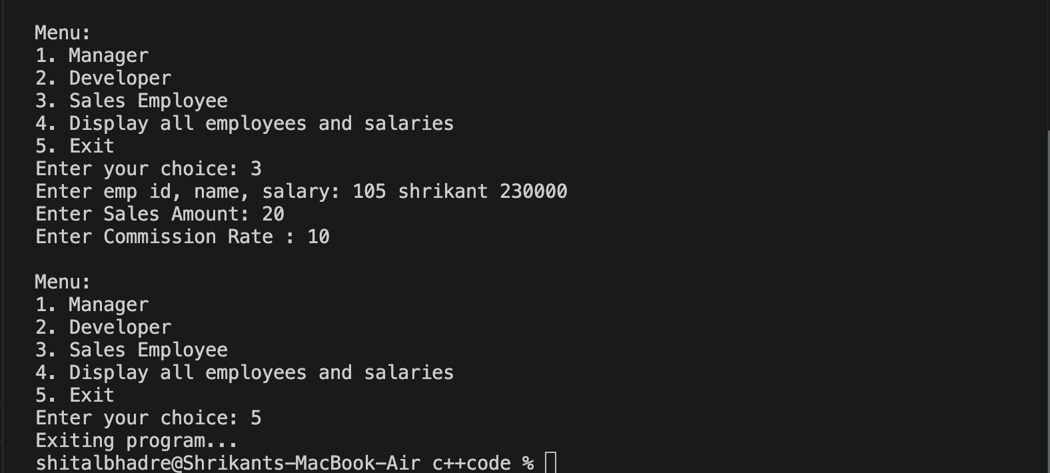

Shital Digambar Bhadre
PRN NO:260740150022

Assignment 7

1 Create a Banking Management System using object-oriented programming concepts.
Create a base class Account containing account number, customer name, and balance.
Derive classes SavingsAccount and CurrentAccount from Account.
Implement functions such as deposit(), withdraw(), and displayAccountDetails().
Override the withdraw() function in both derived classes to demonstrate runtime polymorphism.
Use a base-class pointer to call the appropriate derived-class functions.
Apply the following validations using exception handling:
Attempt to withdraw an amount greater than the available balance.
Deposit amount should be greater than zero.
Withdraw amount should be greater than zero.
Account number should be valid.
Create and handle appropriate user-defined exceptions.

#include <iostream>
#include <string>
#include <stdexcept>

using namespace std;

class Account
{
public:
int accountNo;
string name;
double balance;

Account(int accountNo, string name, double balance)
{
this->accountNo = accountNo;
this->name = name;
this->balance = balance;
}

virtual ~Account() = 0;

void deposit(double amount)
{
if (amount <= 0)
{
throw invalid_argument("Amount must be greater than zero");
}
balance += amount;
cout << "Deposit successful\n";
}

virtual void withdraw(double amount) = 0;

virtual void display()
{
cout << "\nAccount No : " << accountNo;
cout << "\nName : " << name;
cout << "\nBalance : " << balance << endl;
}
};

Account::~Account() {}

class SavingsAccount : public Account
{
public:
double interestRate;

SavingsAccount(int accountNo, string name, double balance, double interestRate)
: Account(accountNo, name, balance)
{
this->interestRate = interestRate;
}

void withdraw(double amount) override
{
if (amount <= 0)
{
throw invalid_argument("Amount must be greater than zero");
}
if (amount > balance)
{
throw runtime_error("Insufficient Balance");
}
if (balance - amount < 500)
{
throw runtime_error("Savings Account must maintain minimum balance of 500");
}
balance -= amount;
cout << "Savings withdrawal successful\n";
}

void display() override
{
cout << "\nAccount Type : Savings Account";
Account::display();
cout << "Interest Rate : " << interestRate << "%\n";
}
};

class CurrentAccount : public Account
{
public:
double maintenanceFee;

CurrentAccount(int accountNo, string name, double balance, double maintenanceFee)
: Account(accountNo, name, balance)
{
this->maintenanceFee = maintenanceFee;
}

void withdraw(double amount) override
{
if (amount <= 0)
{
throw invalid_argument("Amount must be greater than zero");
}
if (amount > balance)
{
throw runtime_error("Insufficient Balance");
}
balance -= amount;
cout << "Current withdrawal successful\n";
}

void display() override
{
cout << "\nAccount Type : Current Account";
Account::display();
cout << "Maintenance Fee : " << maintenanceFee << "\n";
}
};

int main()
{
Account *accounts[10] = {nullptr};
int count = 0;
int choice;

do
{
cout << "\n===== BANKING SYSTEM =====";
cout << "\n1. Create Account";
cout << "\n2. Deposit";
cout << "\n3. Withdraw";
cout << "\n4. Display All Accounts";
cout << "\n5. Exit";
cout << "\nEnter choice: ";
cin >> choice;

try
{
switch (choice)
{
case 1:
{
if (count >= 10)
{
throw runtime_error("Array full. Cannot create more accounts.");
}
int no, type;
string accName;
double balance;
cout << "Enter Name: ";
cin >> accName;
cout << "Enter Account Number: ";
cin >> no;
if (no <= 0)
{
throw invalid_argument("Invalid Account Number");
}

int exists = 0;
for (int i = 0; i < count; i++)
{
if (accounts[i]->accountNo == no)
{
exists = 1;
break;
}
}
if (exists == 1)
{
throw runtime_error("Account already exists");
}

cout << "Enter Balance: ";
cin >> balance;
if (balance < 0)
{
throw invalid_argument("Amount must be greater than zero");
}

cout << "\n1. Savings Account";
cout << "\n2. Current Account";
cout << "\nEnter type: ";
cin >> type;

switch (type)
{
case 1:
{
if (balance < 500)
{
throw runtime_error("Savings Account must maintain minimum balance of 500");
}
double rate;
cout << "Enter Interest Rate (%): ";
cin >> rate;
accounts[count] = new SavingsAccount(no, accName, balance, rate);
cout << "Savings Account Created\n";
count++;
break;
}
case 2:
{
double fee;
cout << "Enter Maintenance Fee: ";
cin >> fee;
accounts[count] = new CurrentAccount(no, accName, balance, fee);
cout << "Current Account Created\n";
count++;
break;
}
default:
throw invalid_argument("Invalid Account Type");
}
break;
}
case 2:
{
int no;
double amount;
cout << "Enter Account Number: ";
cin >> no;
cout << "Enter Deposit Amount: ";
cin >> amount;

int found = 0;
for (int i = 0; i < count; i++)
{
if (accounts[i]->accountNo == no)
{
accounts[i]->deposit(amount);
found = 1;
break;
}
}
if (found == 0)
{
throw runtime_error("Invalid Account Number");
}
break;
}
case 3:
{
int no;
double amount;
cout << "Enter Account Number: ";
cin >> no;
cout << "Enter Withdrawal Amount: ";
cin >> amount;

int found = 0;
for (int i = 0; i < count; i++)
{
if (accounts[i]->accountNo == no)
{
accounts[i]->withdraw(amount);
found = 1;
break;
}
}
if (found == 0)
{
throw runtime_error("Invalid Account Number");
}
break;
}
case 4:
{
if (count == 0)
{
cout << "No accounts stored.\n";
}
else
{
for (int i = 0; i < count; i++)
{
accounts[i]->display();
}
}
break;
}
case 5:
cout << "Thank You!\n";
break;
default:
throw invalid_argument("Invalid Choice");
}
}
catch (const invalid_argument &e)
{
cout << "Input Error: " << e.what() << "\n";
}
catch (const runtime_error &e)
{
cout << "Runtime Error: " << e.what() << "\n";
}
catch (const exception &e)
{
cout << "General Error: " << e.what() << "\n";
}

} while (choice != 5);

for (int i = 0; i < count; i++)
{
delete accounts[i];
}
return 0;
}

Output:
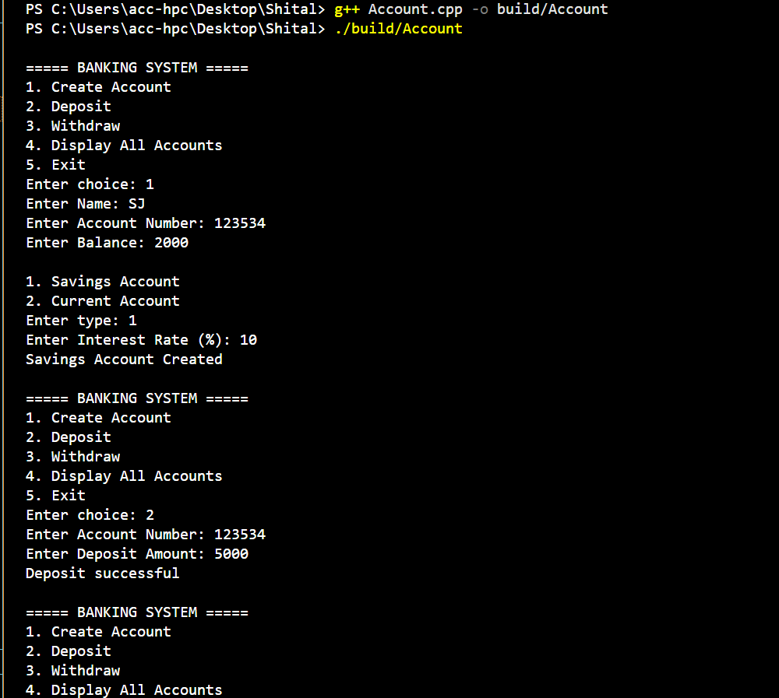

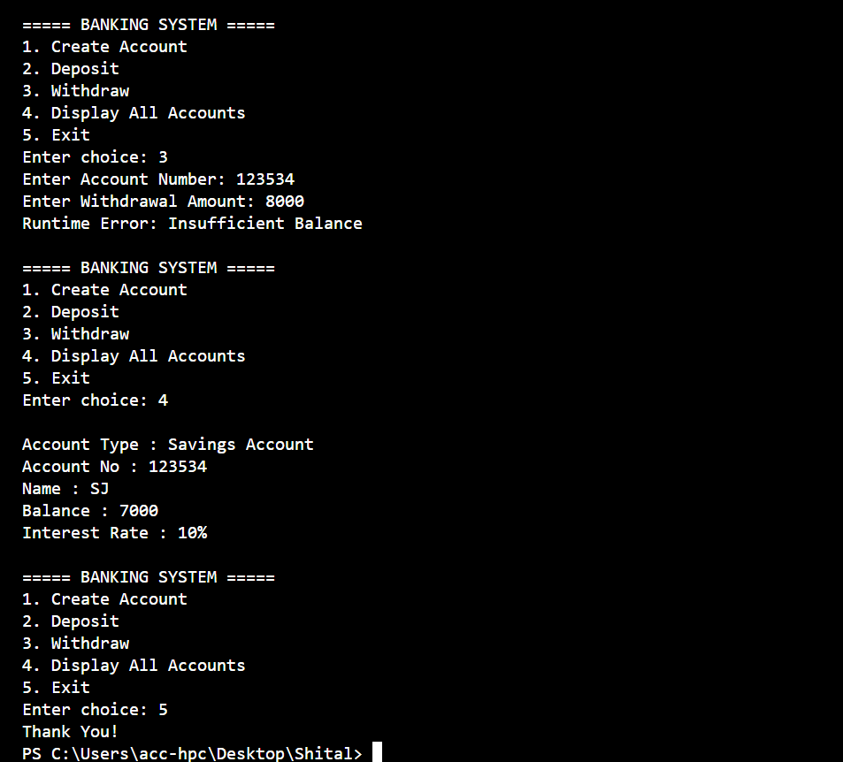

2.Division by Zero
Write a C++ program to accept two integers from the user and perform division. Use exception handling to handle the situation when the denominator is zero.
Requirements:
Accept numerator and denominator.
If denominator is 0, throw an exception.
Display an appropriate error message using catch.
Otherwise, display the result.
#include<iostream>
using namespace std;
int main()
{
int no1, no2;
cout << "\n\t Enter Number and denomintor ";
try {
cin >> no1 >> no2;
if (no2 == 0)
throw 100;
if (no2 < 0)
throw "No Is Negitive ";
if (no2 == 10)
throw 10.5;

cout << "\n\n\t Result " << (no1 / no2);
}
catch (int no) {
cout << "\n\t Enter Correct denominator ";
}
catch (...) {
cout << "\n\tdenominator not Negative ";
}

}

Output
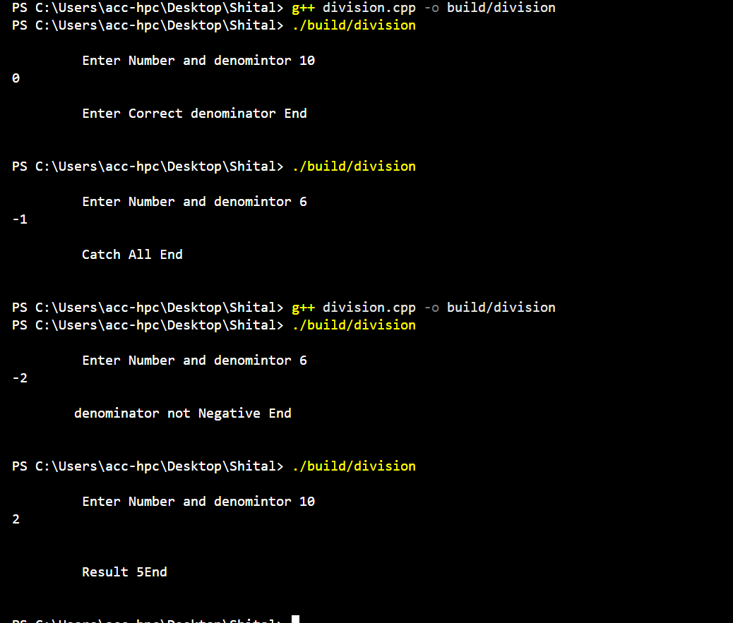

3. Bank Account Withdrawal
Create a class BankAccount with members such as accountNumber and balance. Implement a withdraw() function.
Write a C++ program where an exception is thrown if:
Withdrawal amount is greater than the available balance.
Withdrawal amount is less than or equal to zero.
Display suitable error messages using catch.

#include <iostream>
#include <string>
using namespace std;

class BankAccount {
private:
string accountNumber;
double balance;

public:
BankAccount(string accNum, double initialBalance) {
accountNumber = accNum;
balance = initialBalance;
}

void withdraw(double amount) {

if (amount <= 0) {
throw "Error: Withdrawal amount must be greater than zero!";
}

if (amount > balance) {
throw "Error: Insufficient balance!";
}

balance -= amount;
cout << "Success! Withdrew " << amount <<endl;
cout<<"New Balance: " << balance << endl;
}
};

int main() {
BankAccount myAccount("ACC123", 500.0);
double amount;

cout << "Enter amount to withdraw: ";
cin >> amount;

try {
myAccount.withdraw(amount);
}
catch (const char* msg) {
cout << msg << endl;
}

return 0;
}

Output
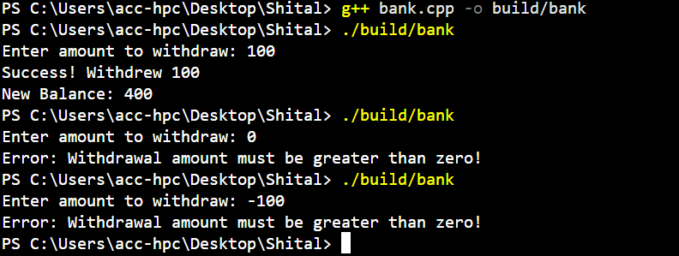

4. Array Index Validation
Write a C++ program to create an integer array of size 10. Accept an index from the user and display the element at that index.
If the user enters an index outside the valid range 0–9, throw an exception.
Requirements:
Create an array of 10 integers.
Accept an index from the user.
Use try, throw, and catch.
Display the corresponding element for a valid index.
Display "Invalid Array Index" for an invalid index.
#include<iostream>
using namespace std;

int main() {
int arr[] = { 43,54,76,23,65,2,45,56,22,5 };
int index;
try {
cout << "\n\t Enter The Index Number ";
cin >> index;
if (index < 0 || index >= 10)
throw out_of_range(" Invalid Array Index ");

cout << "\n\t Value At " << index << " Is " << arr[index];
}
catch (out_of_range e) {
cout << "ERROR : " << e.what();
}
cout << "\n\n\n";

}

Output:
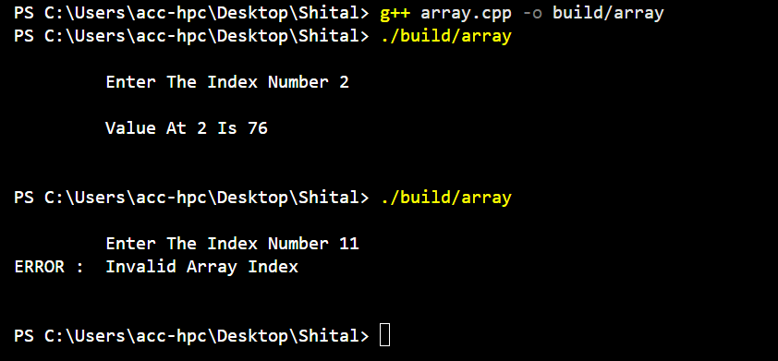

5. Friend Class
Box and BoxCalculator
Suppose the Box class contains private dimensions. We want another class, BoxCalculator, to access those private members and calculate the volume.
Box
----------------
private:
length
width
height
|
| friend
↓
BoxCalculator
----------------
calculateVolume()

#include <iostream>
using namespace std;

class Box {

int length, width, height;

public:
Box() {
length = 0;
width = 0;
height = 0;
}

Box(int l, int w, int h) {
this->length = l;
this->width = w;
this->height = h;
}

friend class BoxCalculator;
};

class BoxCalculator {
public:

BoxCalculator() {}

void Display(const Box& b) {
cout << "\n\t Box length is: " << b.length;
cout << "\n\t Box width is: " << b.width;
cout << "\n\t Box height is: " << b.height << endl;
}
};

int main() {
Box b1(10, 4, 5);
BoxCalculator calc;

calc.Display(b1);
return 0;
}

Output:
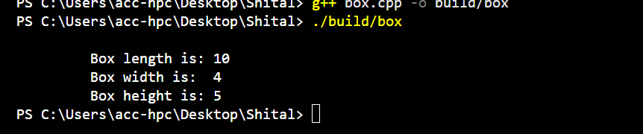

q6.Employee class using dynamic cast.

#include <iostream>
#include <string>
using namespace std;

class employee {
private:
static int count;
int id;
string ename;

protected:
double salary;

public:
employee(string name, double sal) : ename(name), salary(sal) {
count++;
id = count;
}

virtual void display() {

cout << "ID: " << id << " | Name: " << ename << " | Base Sal: " << salary << endl;
}

virtual ~employee() { }
};

int employee::count = 100;

class manager : public employee {
public:
manager(string name, double sal) : employee(name, sal) {}

void assignTasks() {
cout << " -> Assign Tasks.\n";
}
};

class developer : public employee {
public:
developer(string name, double sal) : employee(name, sal) {}

void resolveBugs() {
cout << " -> Resolve Bugs.\n";
}
};

class salesemp : public employee {
public:
salesemp(string name, double sal) : employee(name, sal) {}

void makeSale() {
cout << " -> Sales Employee.\n";
}
};

int main() {
employee* emp[3] = {
new manager("Ram", 80000), // Gets ID: 101
new developer("sham", 65000), // Gets ID: 102
new salesemp("dhyan", 50000) // Gets ID: 103
};

cout << "--- Dynamic Cast ---\n\n";

for (int i = 0; i < 3; i++) {
emp[i]->display();

if (manager* mptr = dynamic_cast<manager*>(emp[i])) {
mptr->assignTasks();
}
else if (developer* dptr = dynamic_cast<developer*>(emp[i])) {
dptr->resolveBugs();
}
else if (salesemp* sptr = dynamic_cast<salesemp*>(emp[i])) {
sptr->makeSale();
}

cout << "-------------------------------------------\n";
}

for (int i = 0; i < 3; i++) {
delete emp[i];
}

return 0;
}

Output:

